# Important Kpi’s from Pizza sales

1. Total_revenue

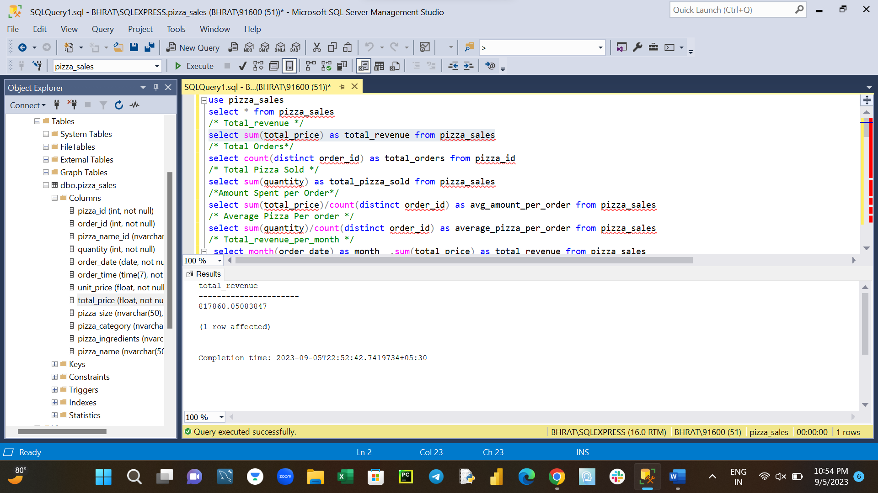select sum(total_price) as total_revenue from pizza_sales

1. Total Orders

select count(distinct order_id) as total_orders from pizza_sales

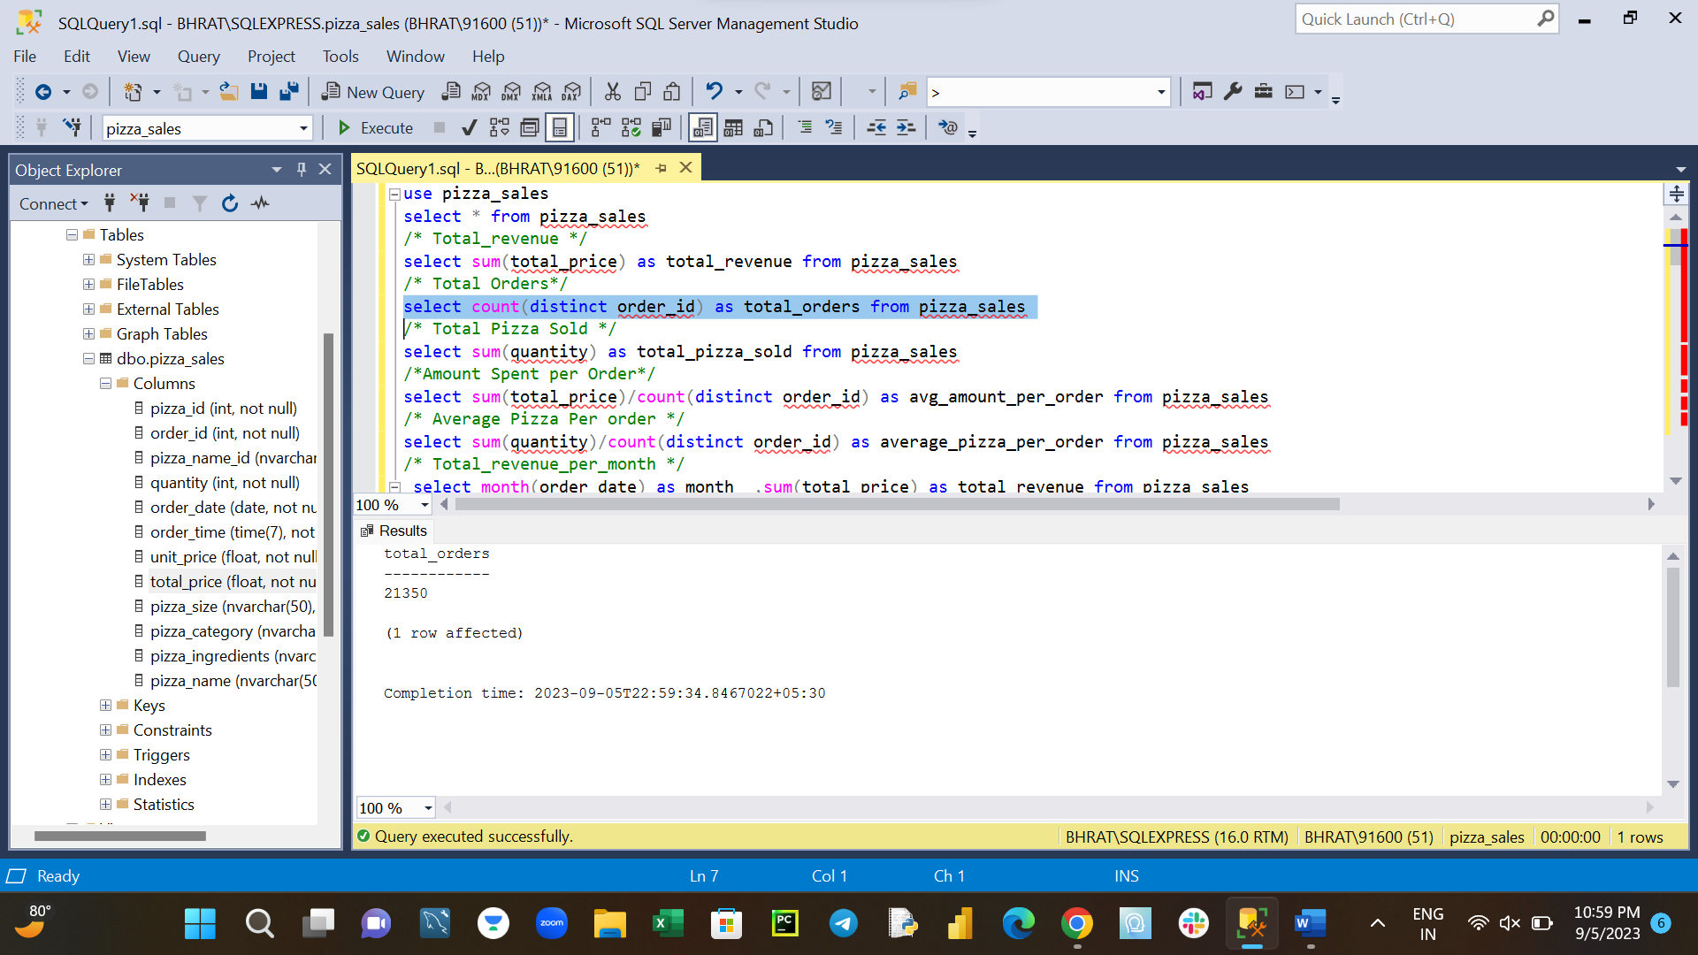

1. Total Pizza Sold

select sum(quantity) as total_pizza_sold from pizza_sales

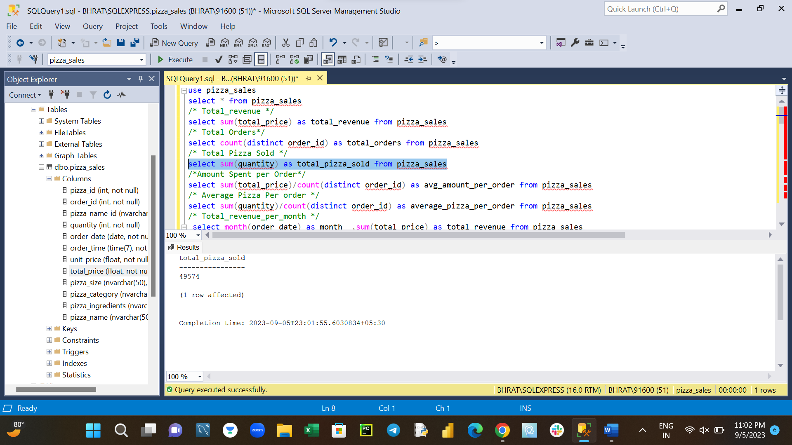

1. Amount Spent per Order

select sum(total_price)/count(distinct order_id) as avg_amount_per_order from pizza_sales

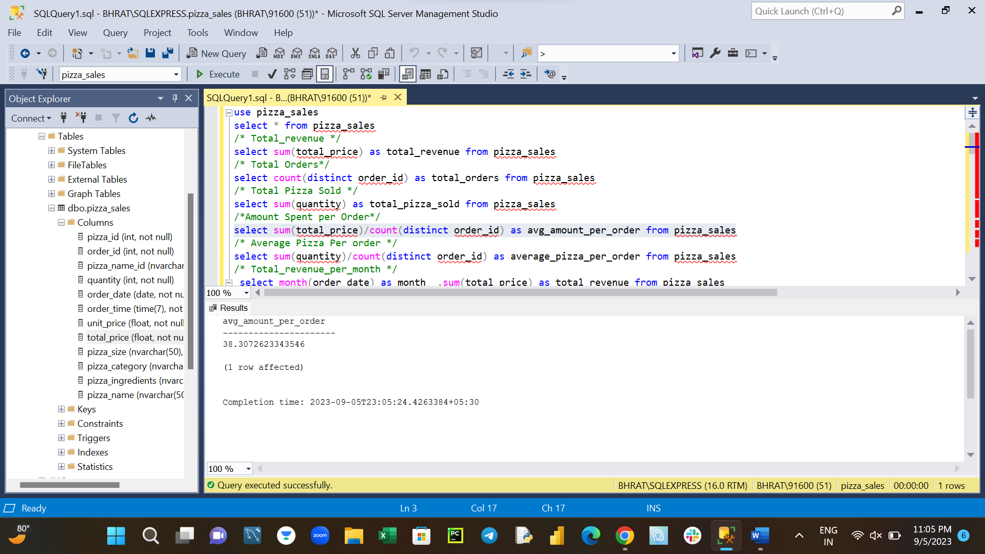

1. Average number of Pizza Per order

select sum(quantity)/count(distinct order_id) as average_pizza_per_order from pizza_sales

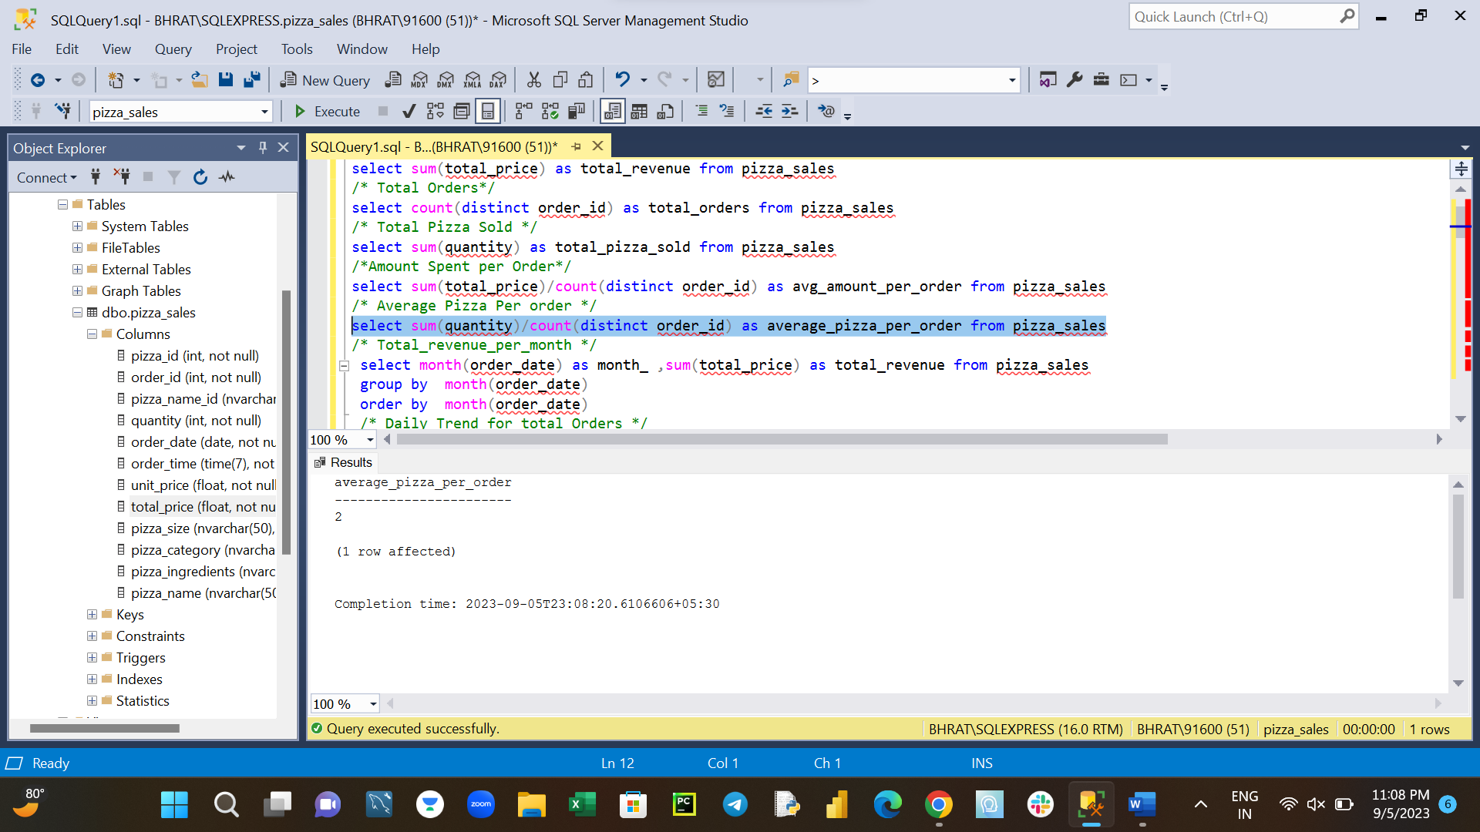

1. Total_revenue_per_month

select month(order_date) as month_ ,sum(total_price) as total_revenue from pizza_sales

group by month(order_date)

order by month(order_date

1. Weekly Trend for total Orders

select datename(dw,order_date) as week_ ,count(distinct order_id) as number_of_customers from pizza_sales

group by datename(dw,order_date)

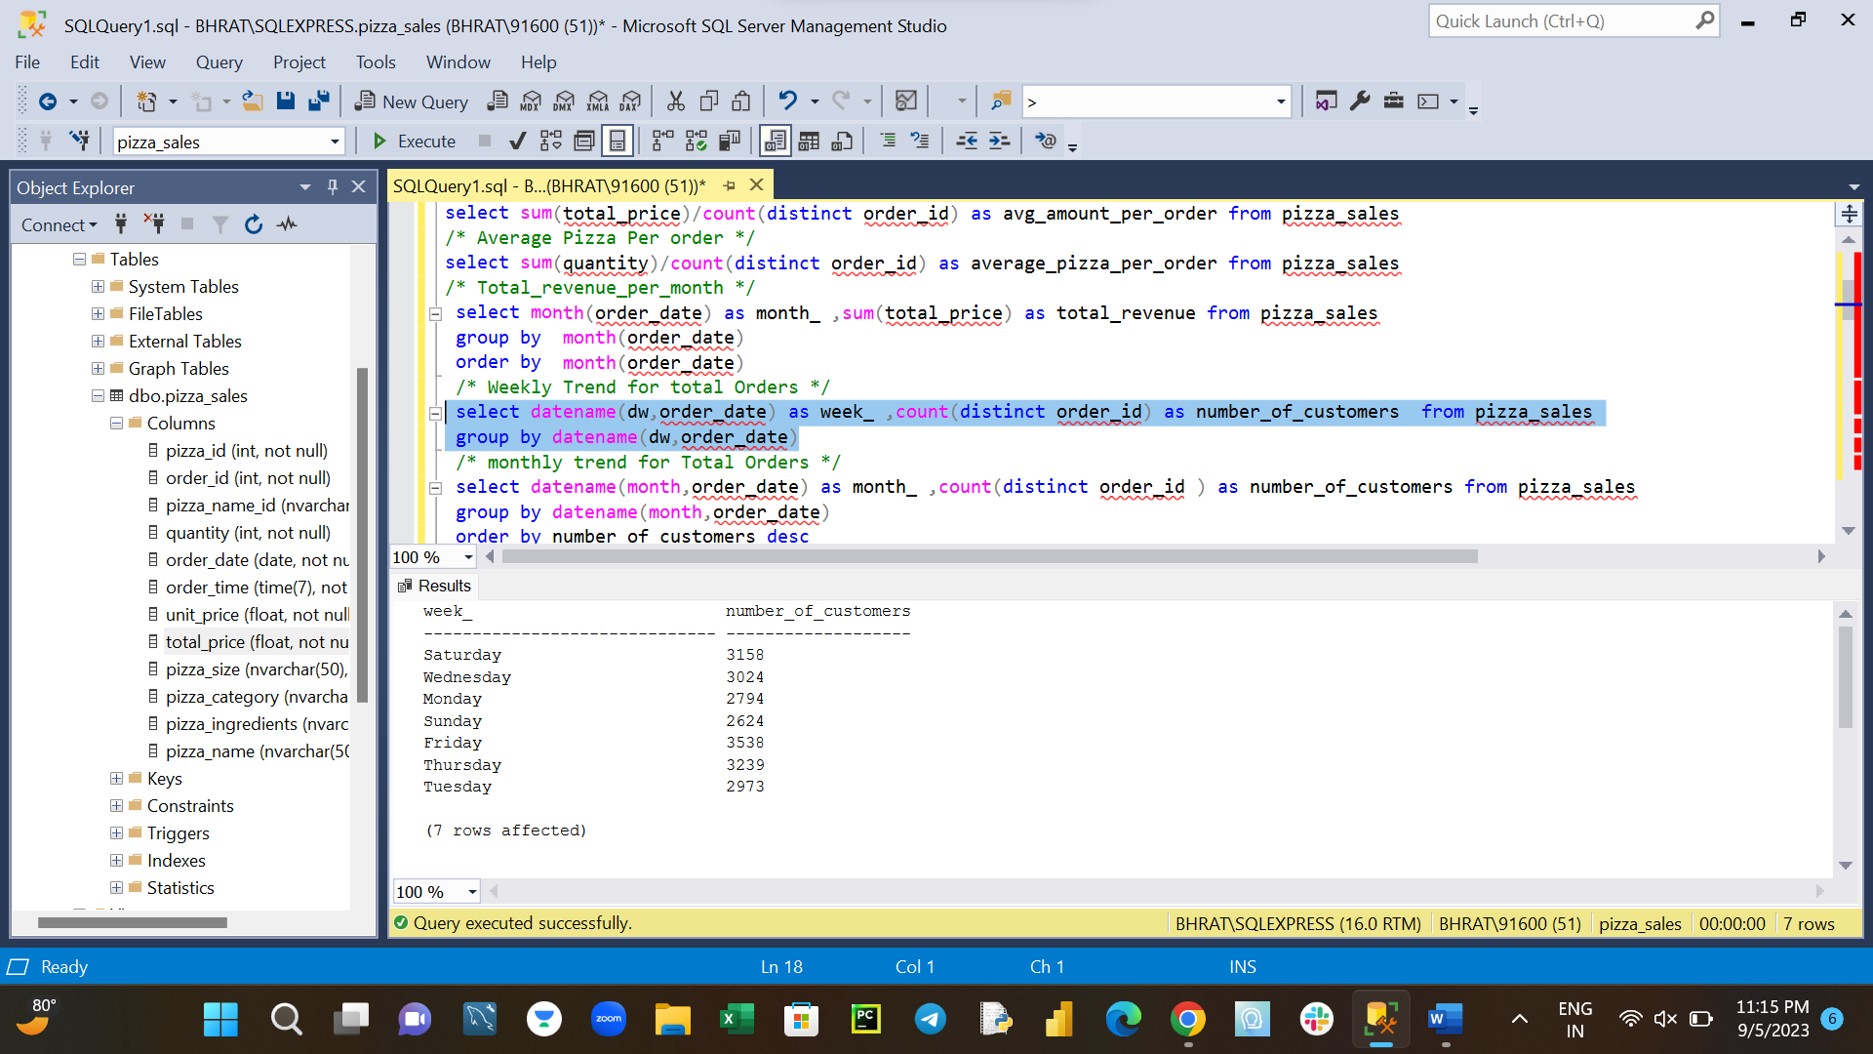

1. Monthly trend for Total Orders

select datename(month,order_date) as month_ ,count(distinct order_id ) as number_of_customers from pizza_sales

group by datename(month,order_date)

order by number_of_customers desc

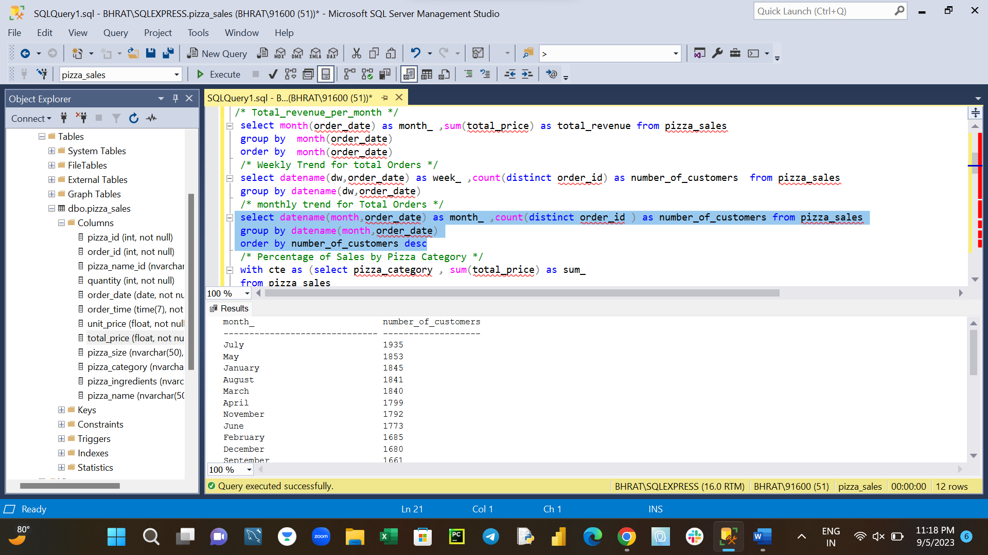

1. Percentage of Sales by Pizza Category

with cte as (select pizza_category , sum(total_price) as sum_

from pizza_sales

group by pizza_category),

cte2 as (select *,sum(sum_) over() as total_order_amount from cte)

select pizza_category, sum_ * 100/total_order_amount as percentage_sales from cte2

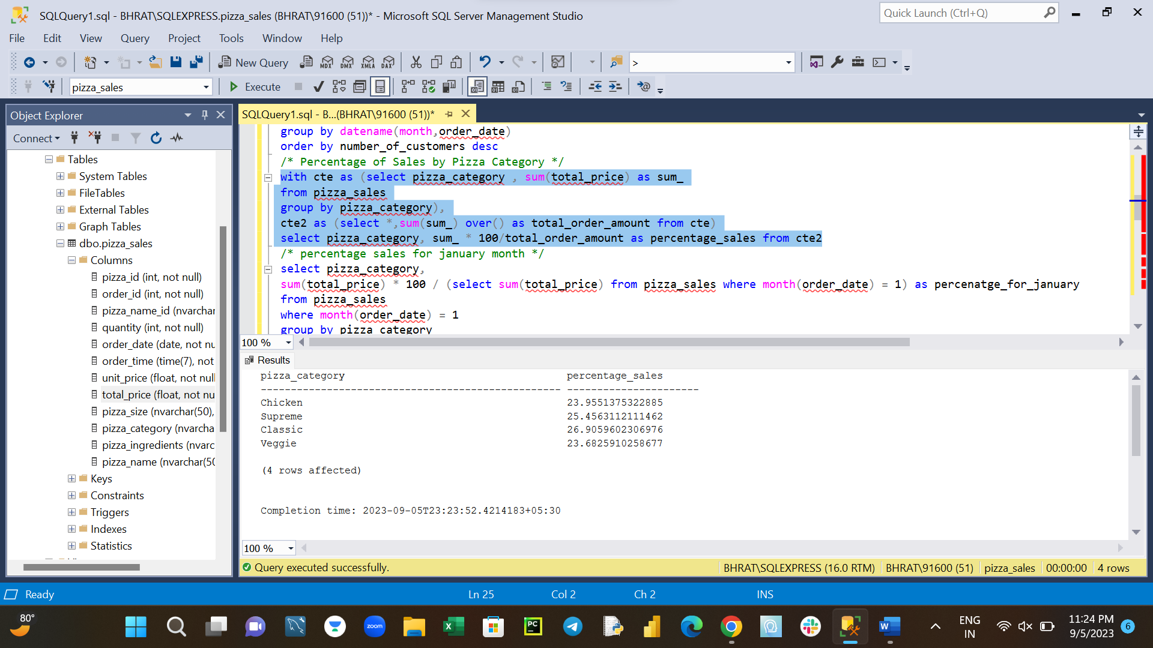

1. Percentage sales for january month

select pizza_category,

sum(total_price) * 100 / (select sum(total_price) from pizza_sales where month(order_date) = 1) as percenatge_for_january

from pizza_sales

where month(order_date) = 1

group by pizza_category

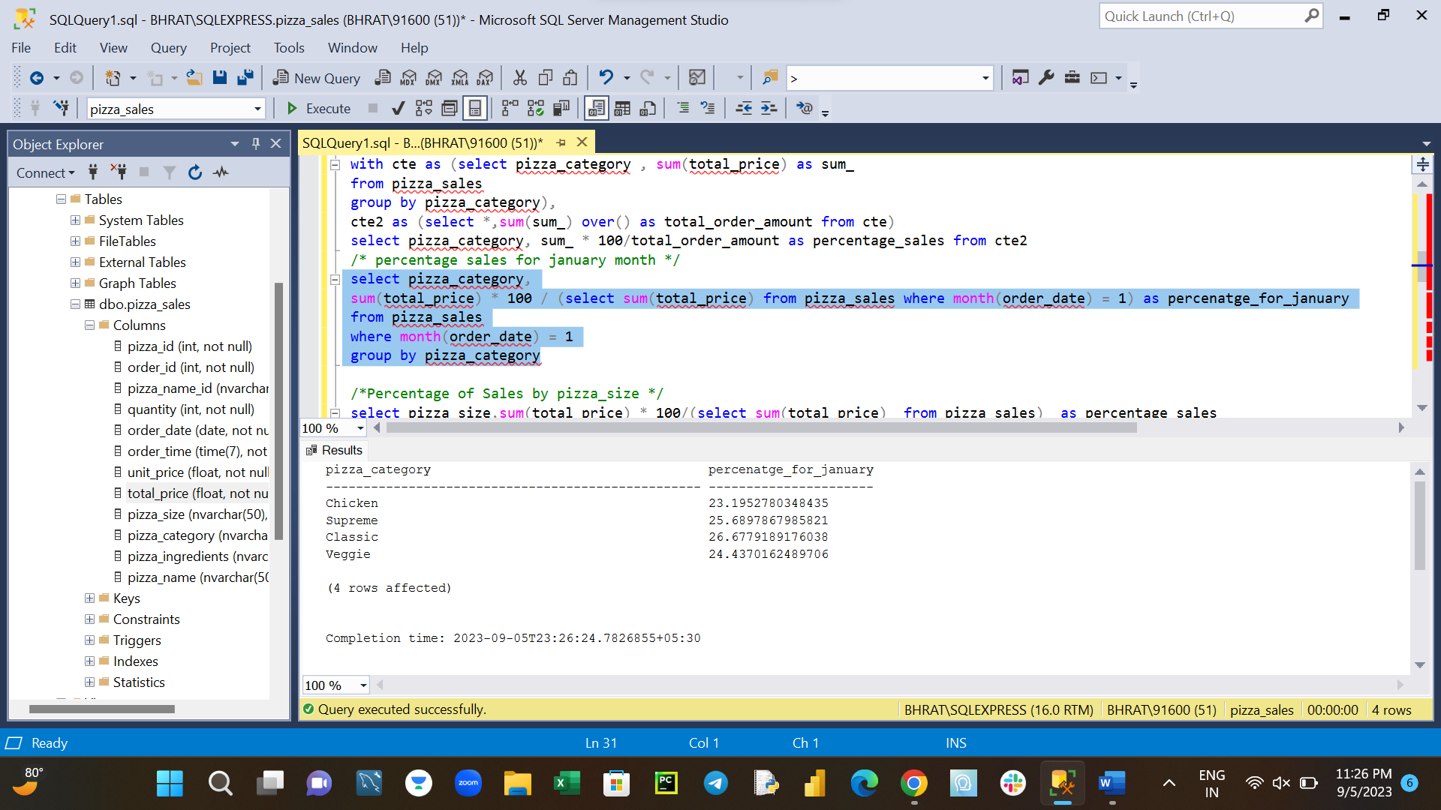

1. Percentage Sales of Pizza by pizza_size

select pizza_size,sum(total_price) * 100/(select sum(total_price) from pizza_sales) as percentage_sales

from pizza_sales

group by pizza_size

order by percentage_sales desc

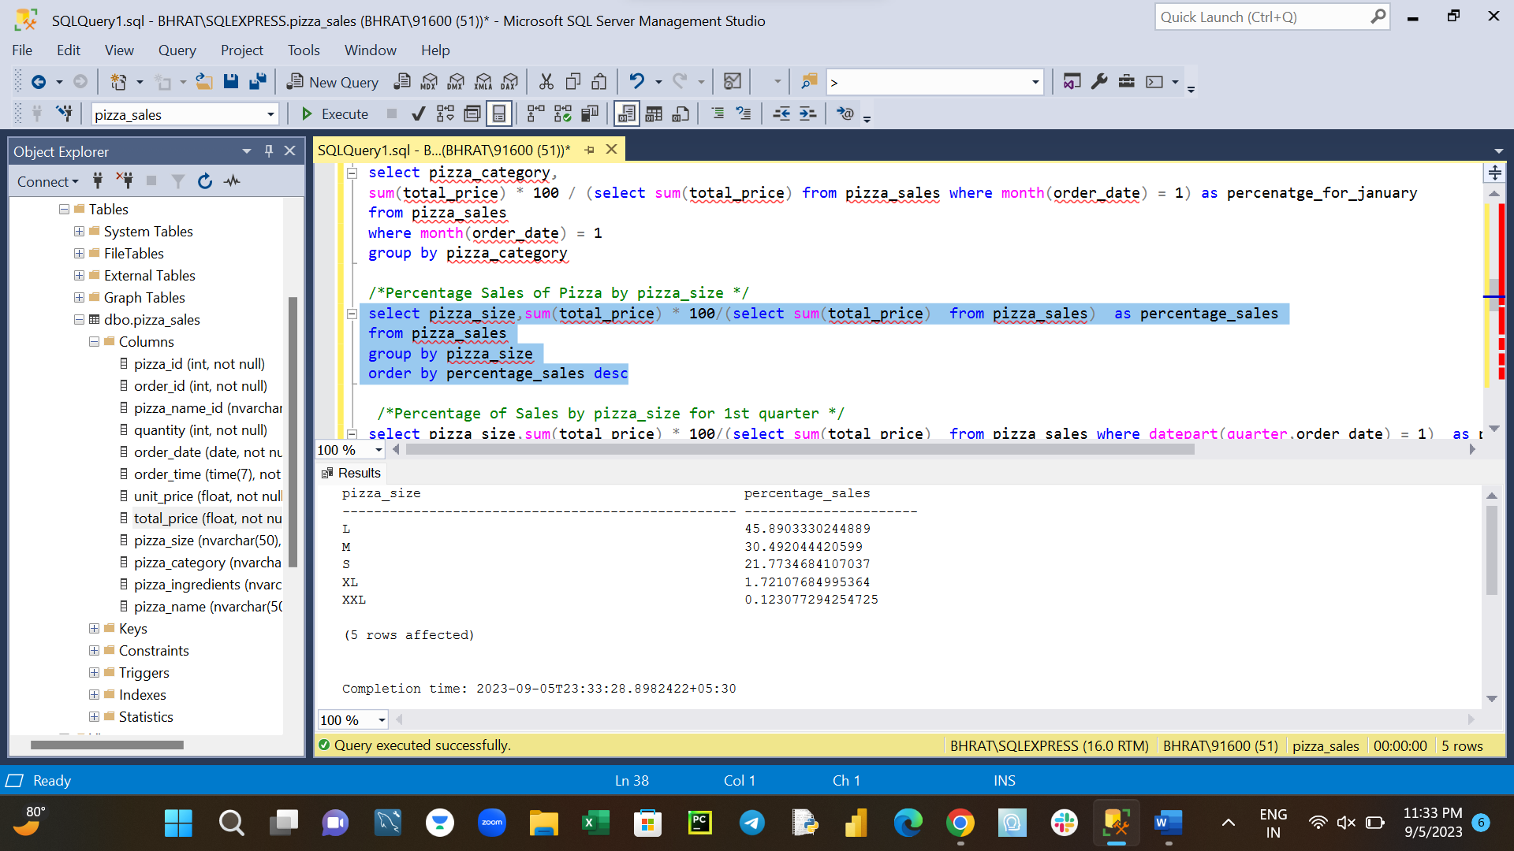

1. Percentage Sales of pizza by pizza_size for 1st quarter

select pizza_size,sum(total_price) * 100/(select sum(total_price) from pizza_sales where datepart(quarter,order_date) = 1) as percentage_sales

from pizza_sales

where datepart(quarter,order_date) = 1

group by pizza_size

order by percentage_sales desc

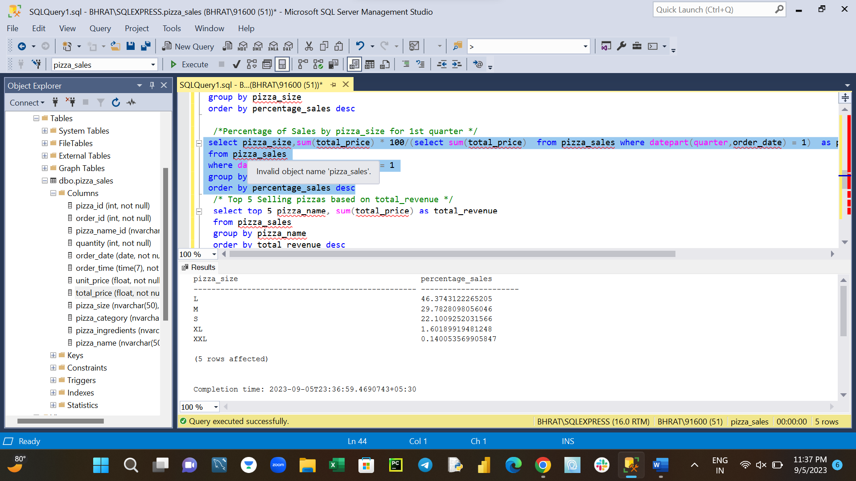

1. Top 5 Selling pizzas based on total_revenue

select top 5 pizza_name, sum(total_price) as total_revenue

from pizza_sales

group by pizza_name

order by total_revenue desc

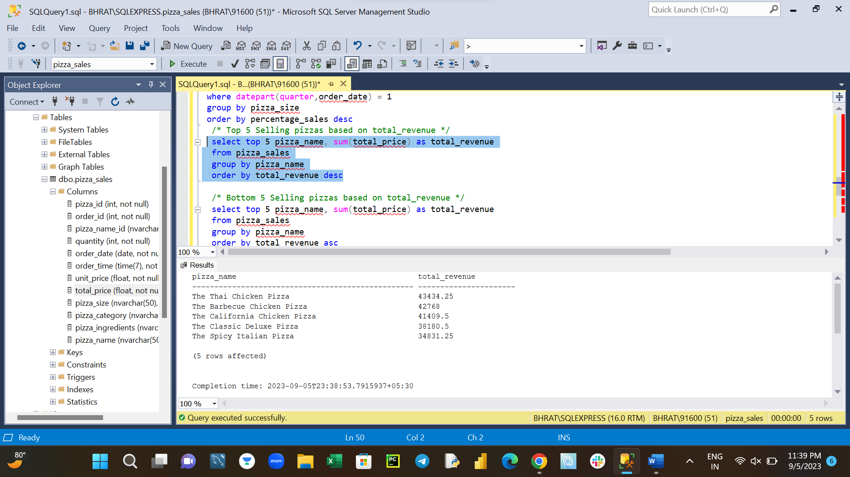

1. Bottom 5 Selling pizzas based on total_revenue

select top 5 pizza_name, sum(total_price) as total_revenue

from pizza_sales

group by pizza_name

order by total_revenue asc

1. Top 5 Selling pizzas based on total_quantity

select top 5 pizza_name, sum(quantity) as total_quantity

from pizza_sales

group by pizza_name

order by total_quantity desc

1. Bottom 5 Selling pizzas based on total_quantity

select top 5 pizza_name, sum(quantity) as total_quantity

from pizza_sales

group by pizza_name

order by total_quantity asc

